**Given the provided data, what are three conclusions we can draw about Kickstarter campaigns?**

1. The timing of the campaign could be *very* consequential. In general, Q4 (October – December) should be avoided as a time frame for launching a Kickstarter campaign. For example, if you are considering Kickstarting a project in the “Theater” category you may have a much better chance of success if you start your camping in Q2 (April – June) than in Q4 (October – December). As you can see in the chart below, more than 30% of all funds are pledged in Q2 and more than 30% of all successful theater projects are launched in Q2.

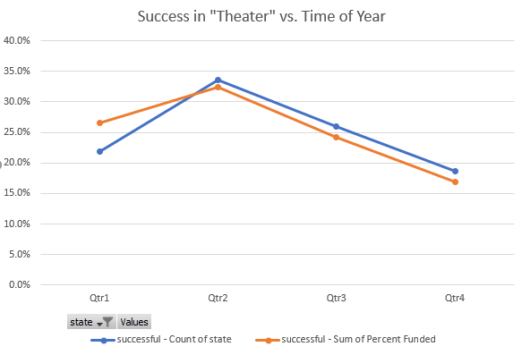

1. Depending on the category that your project is in, the best time of year to launch may vary. For example, if you are considering Kickstarting a project in the “Photography” category you may have a much better chance of success if you start your camping in Q1 (January - March) than in Q3 (July – September).

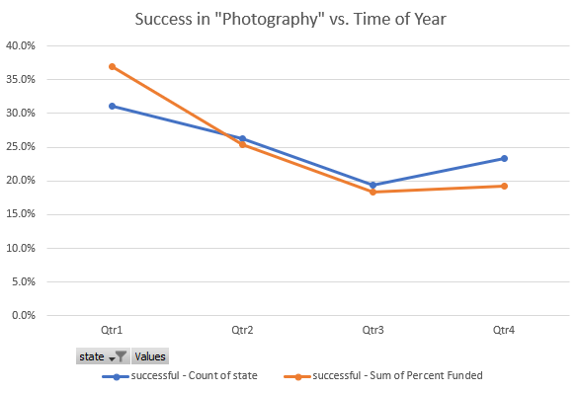

1. If you’re a faith or jazz music artist, consider using another fund-raising method. Based on the data, you have a much better chance of success with some genres of music over others. For the projects considered, no projects in the “Faith” or “Jazz” genres were successful.

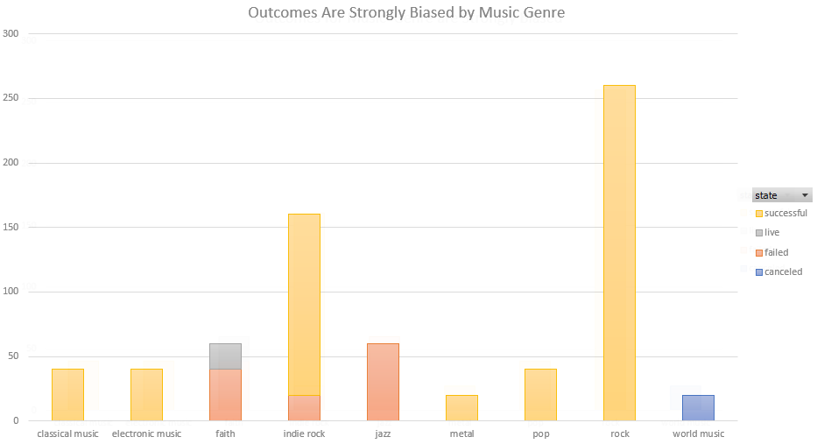

**What are some limitations of this dataset?**

* The data for 2017 is not complete, so analysis of year-of-year trends that include 2017 are not possible.
* There are no data points where the Project Name is in a language other than English. This may skew results when trying to draw correlations between countries that include non english-speaking countries.

**What are some other possible tables and/or graphs that we could create?**

* One possible pivot chart which summarizes the data for the different Categories well includes the Categories as rows and Count of State and Average of Percent Funded as columns. This gives a good overall count of the breakdown of the types of projects that Kickstarter is used for, and it shows how well the product categories tend to do. For example, the Technology and Games tend to have very high funding percentage.

